Create Automated Security Testing

Overview

In modern DevSecOps, automated security testing is a cornerstone of building secure applications. This module demonstrates how to integrate three layers of security testing into a GitHub Actions pipeline:
- Software Composition Analysis (SCA) – detects vulnerable dependencies.
- Static Application Security Testing (SAST) – analyzes source code for security flaws.
- Dynamic Application Security Testing (DAST) – simulates real-world attacks against a running application using OWASP ZAP.

By the end of this documentation, you will understand how to build a CI/CD pipeline that automatically enforces security checks on every pull request, ensuring vulnerabilities are identified early in the software development lifecycle.

Prerequisites

- A GitHub account.
- Basic knowledge of JavaScript/Node.js (familiarity with package.json and Express.js).
- Understanding of GitHub Actions workflows (YAML syntax).
- Familiarity with fundamental security concepts:
  - SCA (Dependency Scanning)
  - SAST (Code Analysis)
  - DAST (Runtime Vulnerability Testing)

Step 1: Create repository

- Create a new repository.

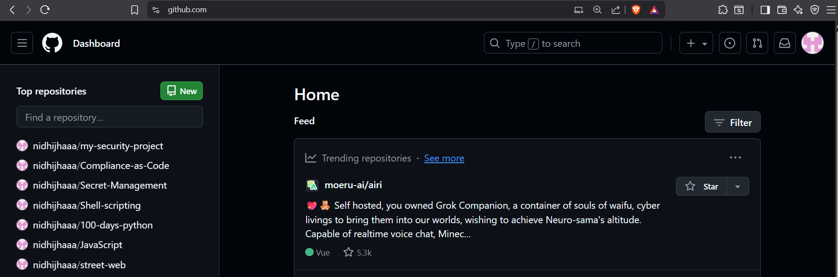

- Add repository name Create repository
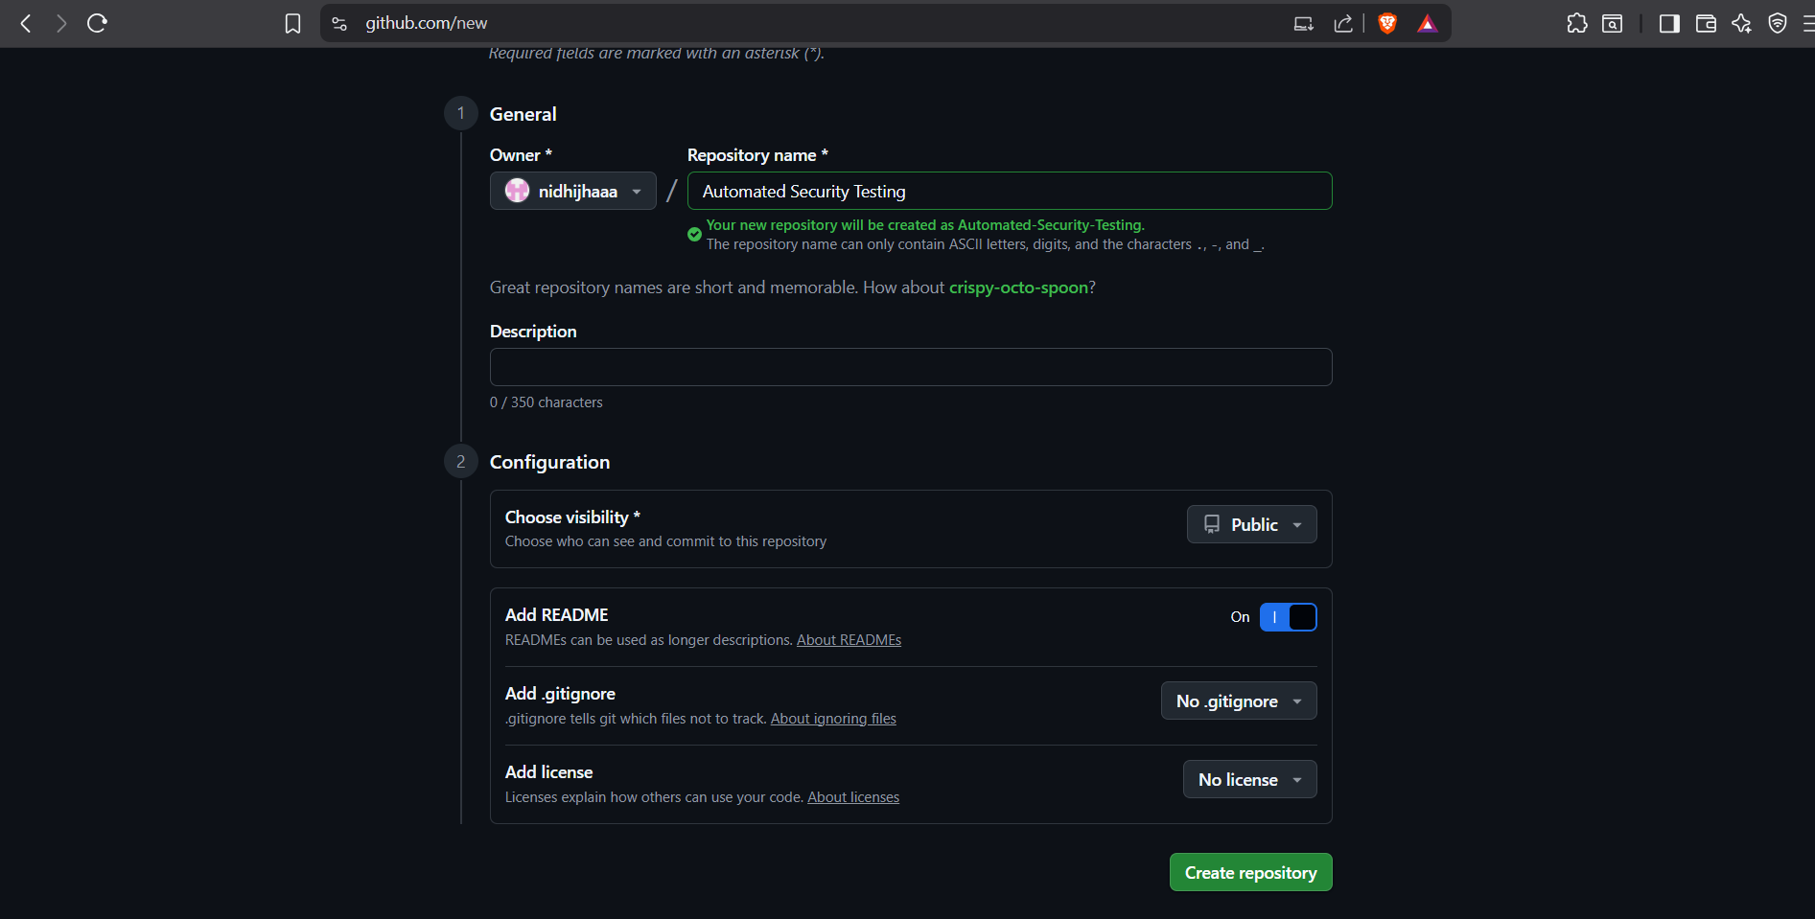

- Click Add file Create new file.
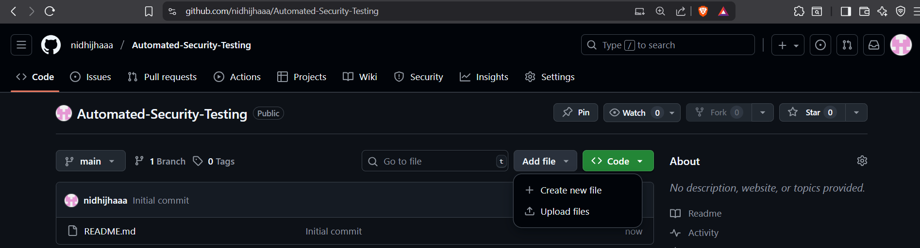

- In your repository, create a new file named package.json.
- Copy and paste the following code to define a simple Express.js server:

{
"name": "my-security-project",
"version": "1.0.0",
"description": "A simple app to test DAST scanning",
"main": "app.js",
"scripts": {
"start": "node app.js",
"test": "echo \"Error: no test specified\" && exit 1"
},
"dependencies": {
"express": "^4.18.0"
}
}

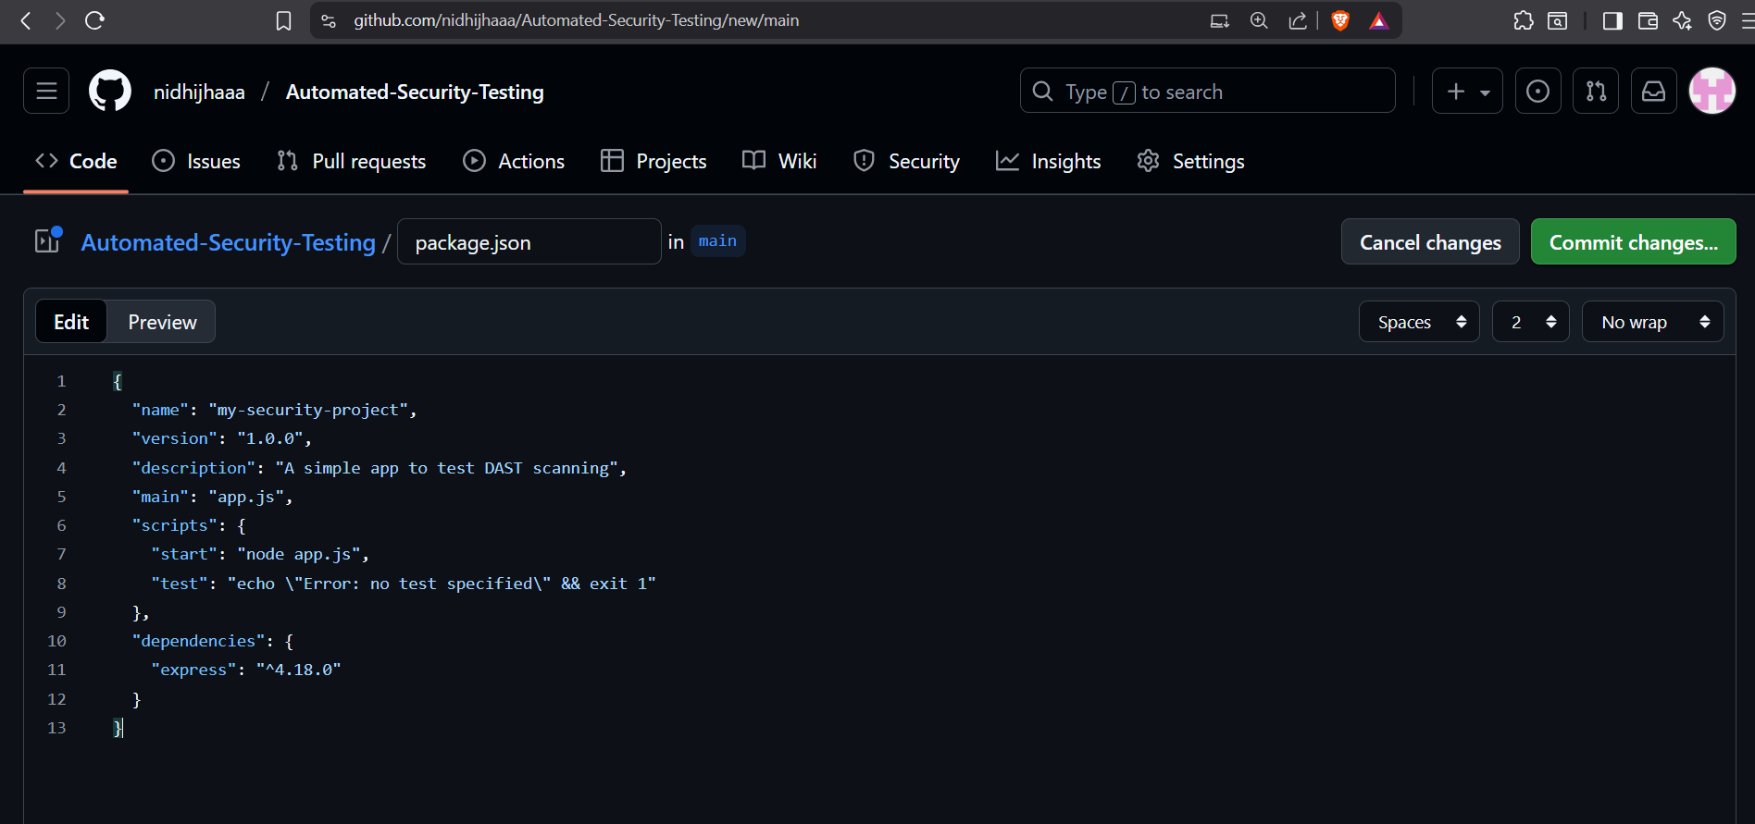

Commit.

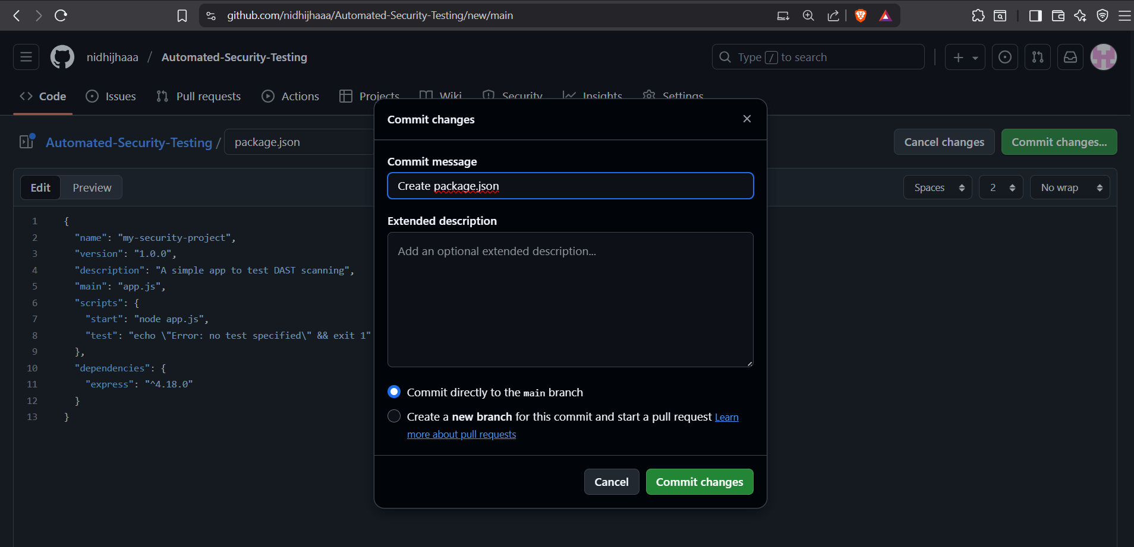

- Create a second file named app.js

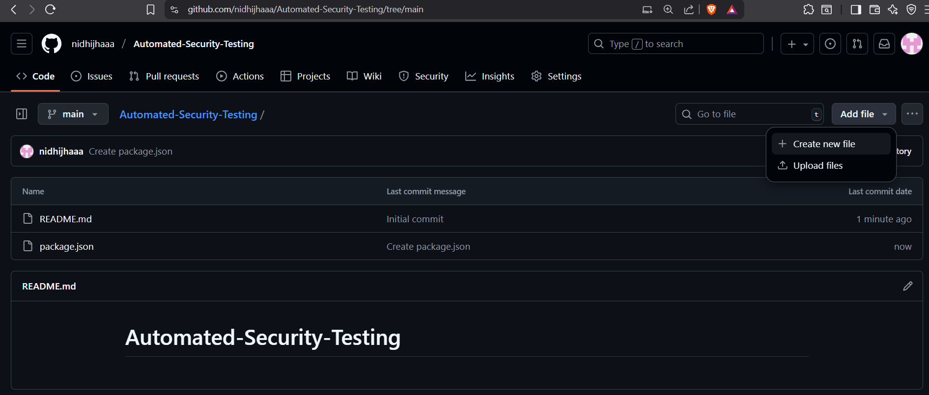

- Copy and paste the following code to create a basic web server with a simple form (which is perfect for ZAP to test):

// app.js - A simple vulnerable app for testing
const express = require('express');
const app = express();
const port = process.env.PORT || 3000;

// Middleware to parse form data
app.use(express.urlencoded({ extended: true }));

// Serve a simple home page
app.get('/', (req, res) => {
res.send(`
<h1>Simple Test App</h1>
<p>This is a test application for DAST scanning.</p>
<form action="/data" method="POST">
<label for="input">Enter some text:</label>
<input type="text" id="input" name="userInput">
<button type="submit">Submit</button>
</form>
`);
});

// A route that echoes user input - a classic XSS test case
app.post('/data', (req, res) => {
const userData = req.body.userInput;
// WARNING: This is intentionally vulnerable for demonstration.
// It reflects user input without sanitization.
res.send(`<p>You entered: ${userData}</p>`);
});

// Start the server
app.listen(port, () => {
console.log(`Test app listening on http://localhost:${port}`);
});

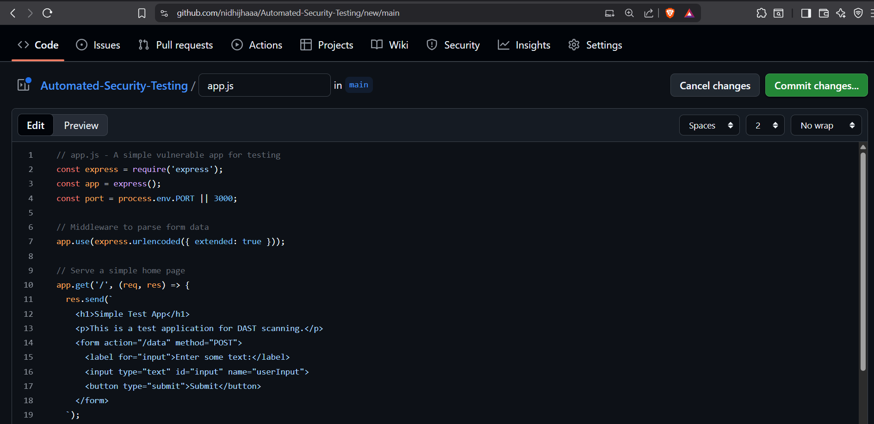

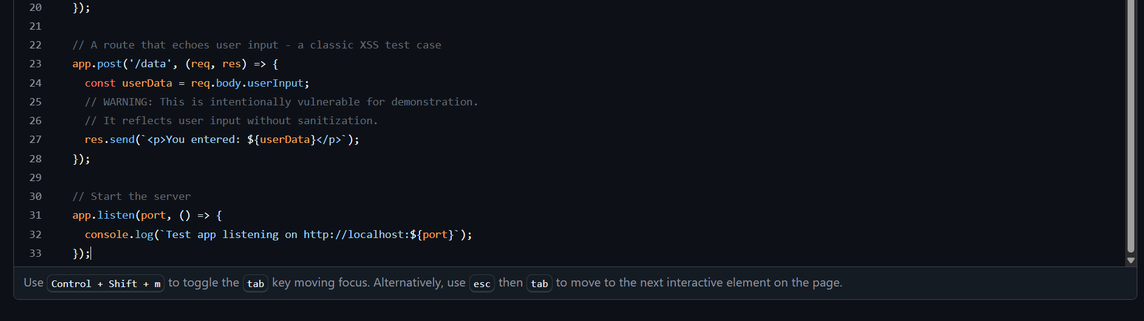

- Commit these files to your main branch.
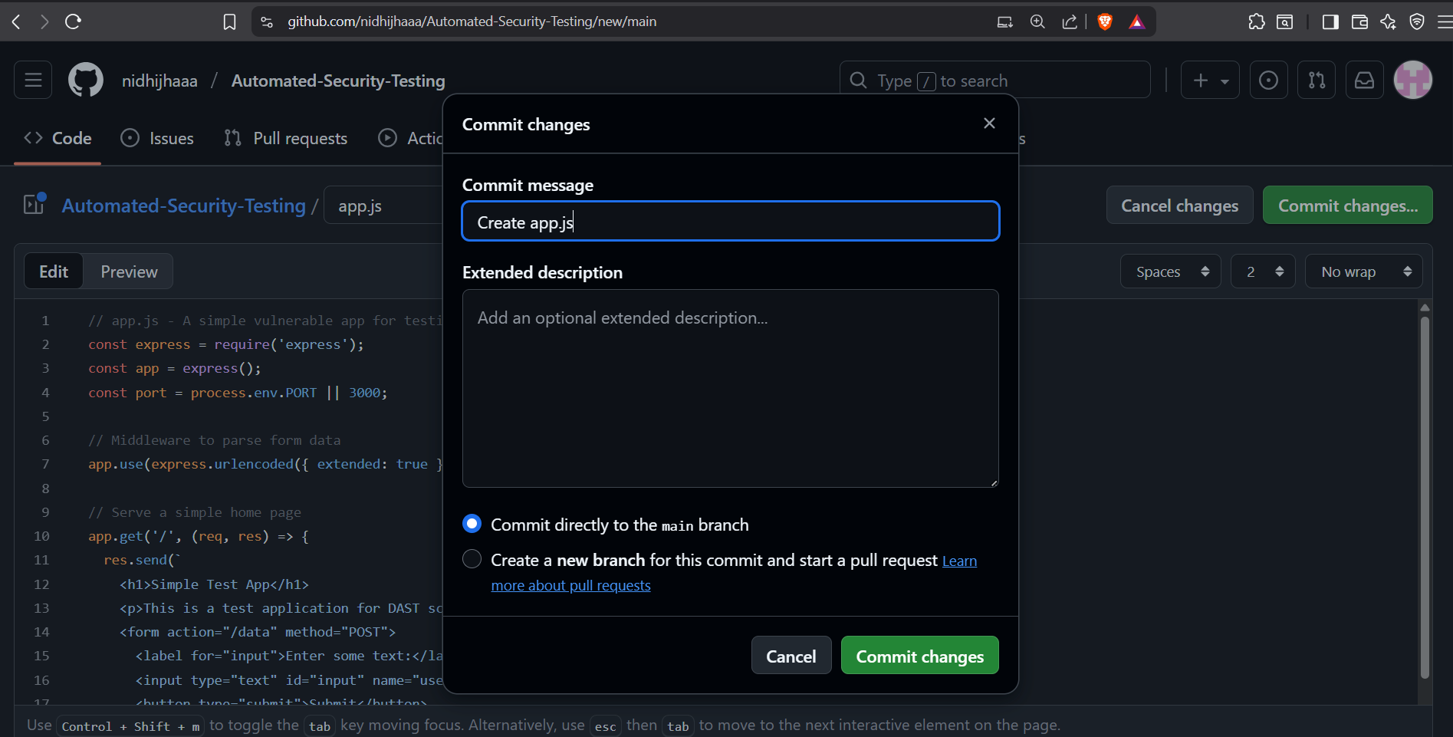

Step 2: Modify the GitHub Actions Workflow for DAST

- To add a new job that starts the application and then scans it with OWASP ZAP.

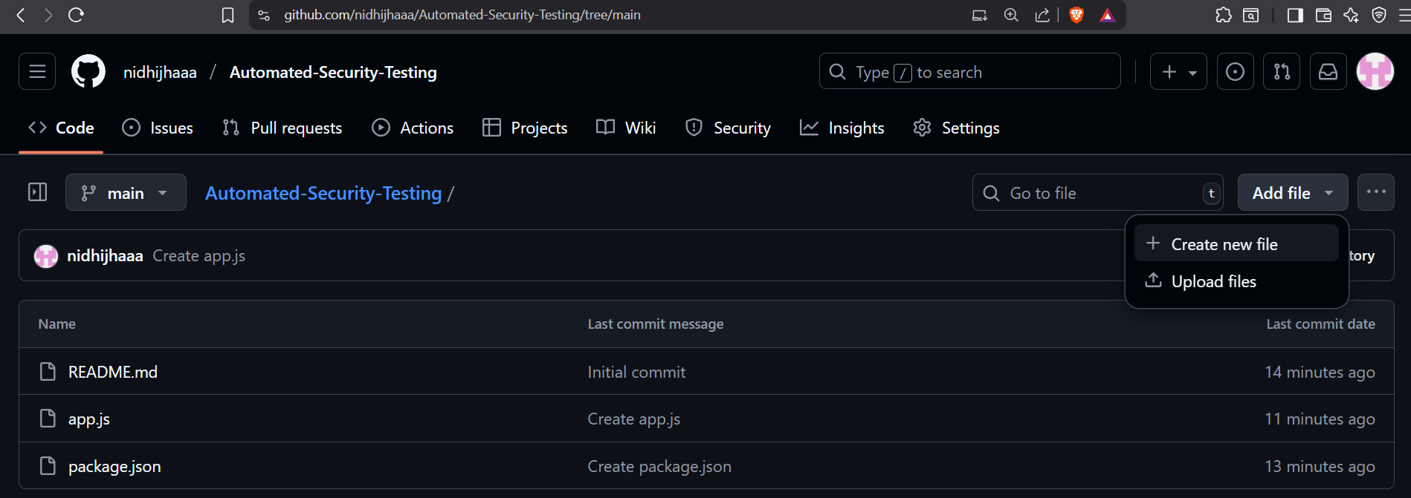

- workflow file: .github/workflows/security-scanning.yml

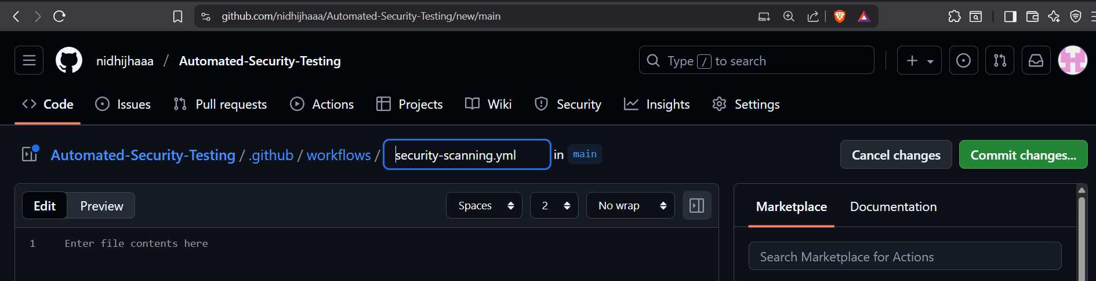

- Add the following new job at the end of the file, after all other jobs.

name: Automated Security Testing

# Trigger the pipeline on every pull request targeting the main branch
on:
pull_request:
branches: [ "main" ]

jobs:
# JOB 1: Dependency Scanning (SCA) - Finds vulnerable libraries
dependency-scan:
name: SCA - Dependency Review
runs-on: ubuntu-latest
steps:
- name: Checkout code
uses: actions/checkout@v4

- name: Setup Node.js
uses: actions/setup-node@v3
with:
node-version: '18'

- name: Install dependencies
run: npm install

- name: Scan for vulnerable dependencies
uses: actions/dependency-review-action@v3
# This action will FAIL the job if it finds new critical vulnerabilities

# JOB 2: Static Analysis (SAST) - Finds bugs in source code
codeql-sast-scan:
name: SAST - CodeQL Analysis
runs-on: ubuntu-latest
permissions:
security-events: write
actions: read
contents: read
steps:
- name: Checkout code
uses: actions/checkout@v4

- name: Initialize CodeQL
uses: github/codeql-action/init@v2
with:
languages: javascript

- name: Perform CodeQL Analysis
uses: github/codeql-action/analyze@v2

# JOB 3: Dynamic Testing (DAST) - Tests the running app
dast-scan:
name: DAST - OWASP ZAP Scan
runs-on: ubuntu-latest
needs: dependency-scan # Wait for dependencies to be installed
steps:
- name: Checkout code
uses: actions/checkout@v4

- name: Setup Node.js
uses: actions/setup-node@v3
with:
node-version: '18'

- name: Install dependencies
run: npm install

- name: Start application server
run: |
echo "Starting the application server..."
nohup npm start > server.log 2>&1 &
echo $! > server.pid
sleep 10

# Check if the server started successfully
if curl -f http://localhost:3000; then
echo "Server is running on port 3000"
else
echo "Server failed to start. Logs:"
cat server.log
exit 1
fi
env:
PORT: 3000

- name: OWASP ZAP Full Scan
uses: zaproxy/action-full-scan@v0.10.0
with:
target: 'http://localhost:3000'
cmd_options: '-a' # Show all results (Pass, Warn, Fail)
fail_action: false # Report findings but don't fail the build

- name: Stop application server
if: always()
run: |
echo "Stopping server..."
kill -TERM $(cat server.pid) 2>/dev/null || true
rm -f server.pid

- name: Upload scan results
if: always()
uses: actions/upload-artifact@v4
with:
name: zap-scan-results
path: |
server.log
.zap/report.html

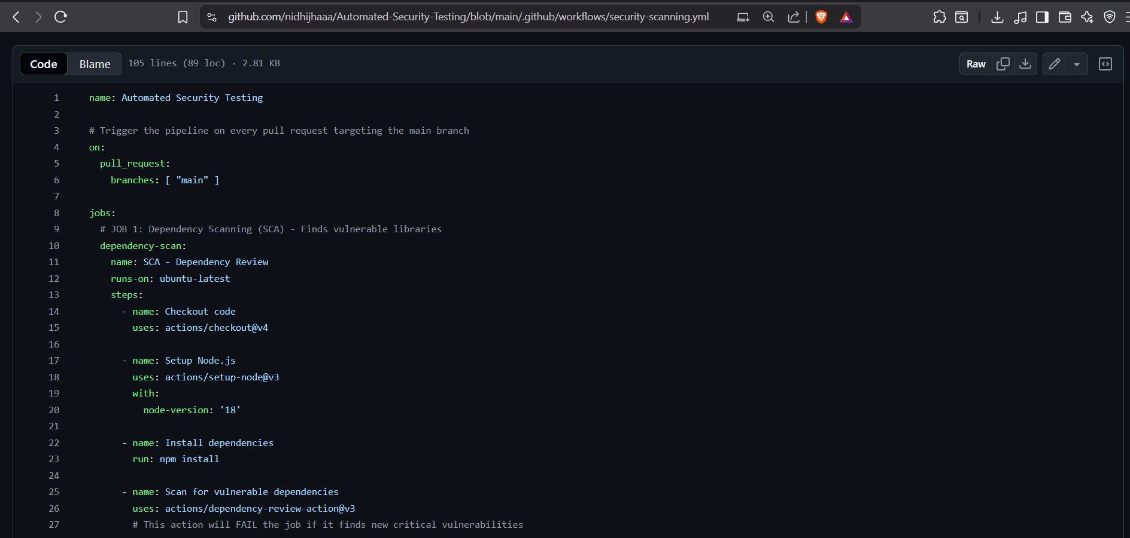

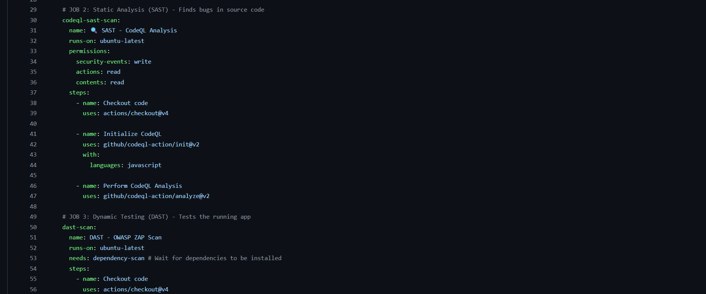

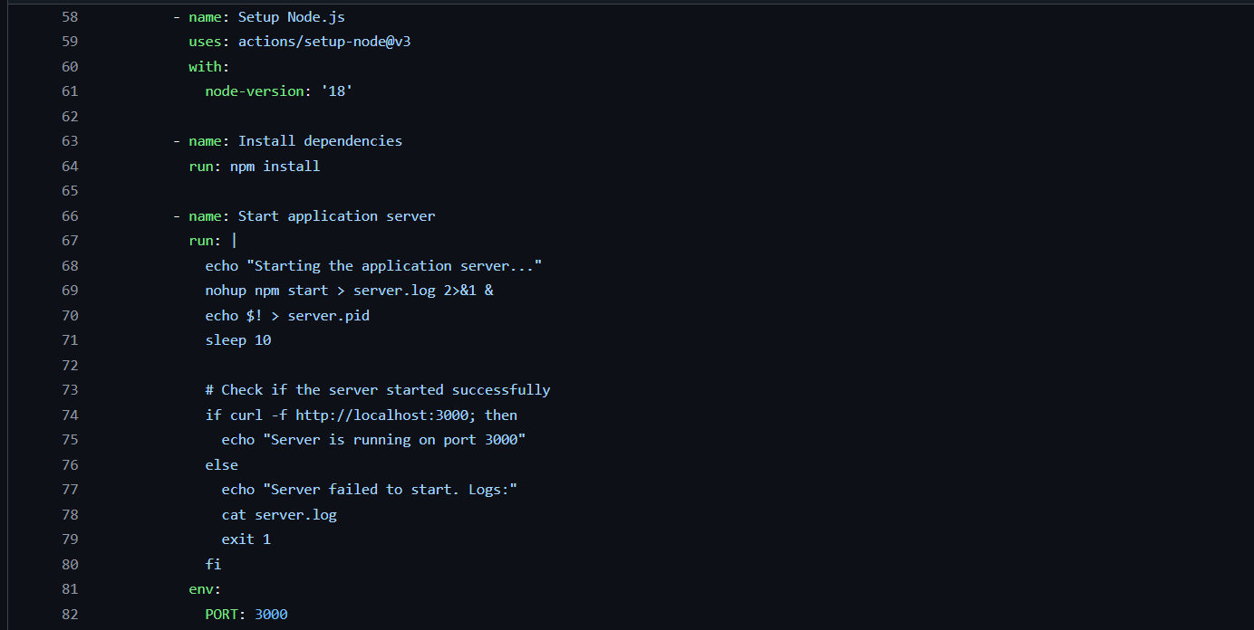

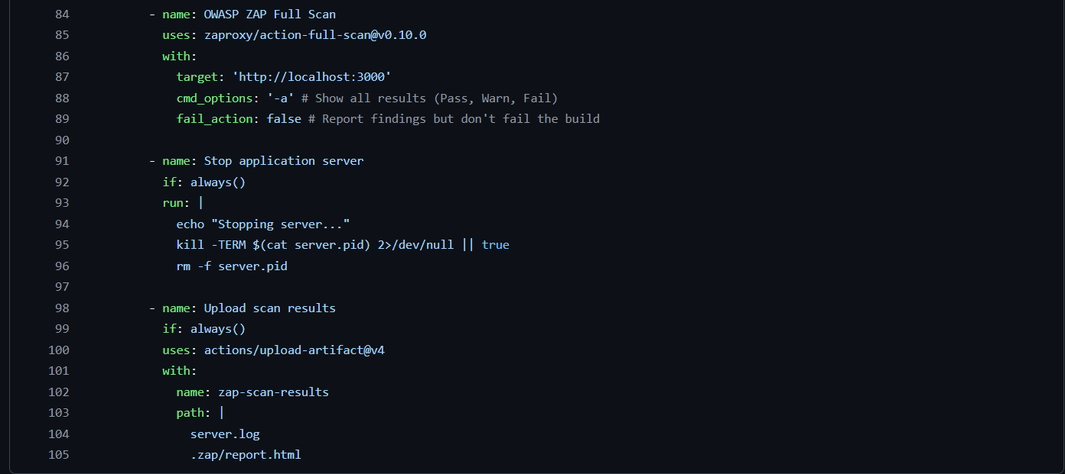

- Commit the change to your workflow file

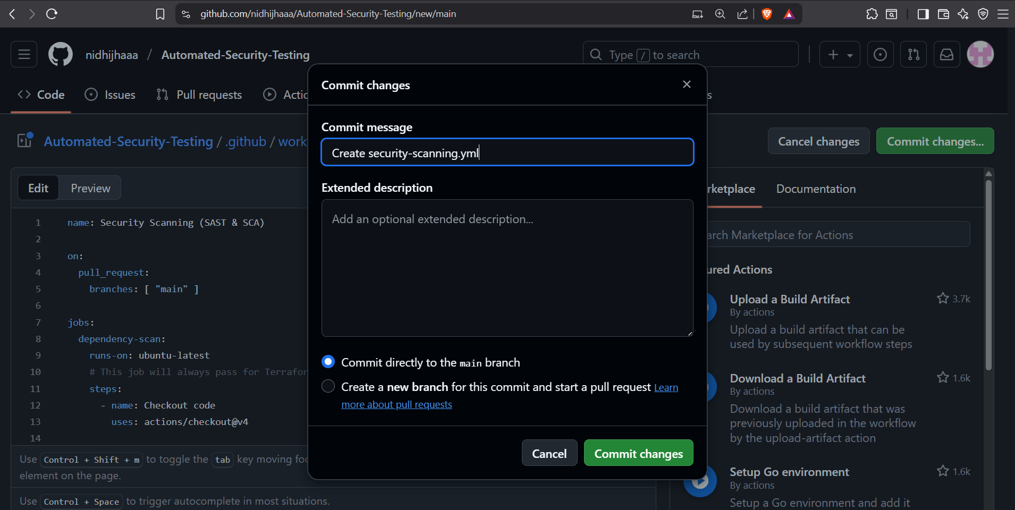

You need to make a change that will trigger the Pull Request workflow.
Make a Simple Change: The easiest way is to edit your README.md file.
- Go to your repository on GitHub.
- Click on the README.md file.
- Click the pencil icon to edit it.
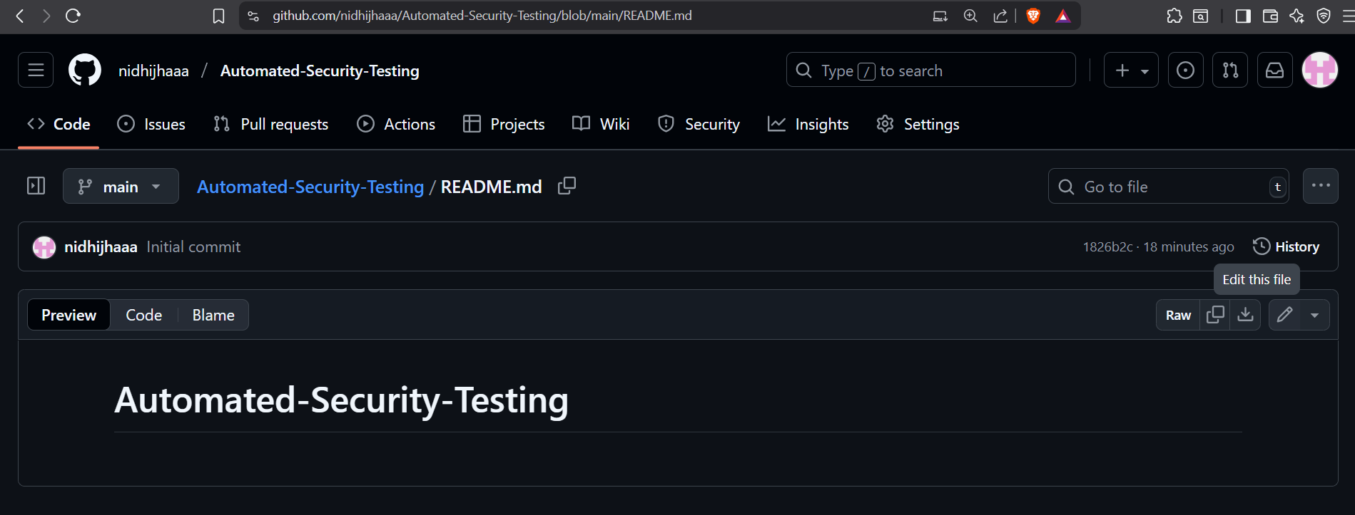

Add any line you want to add.

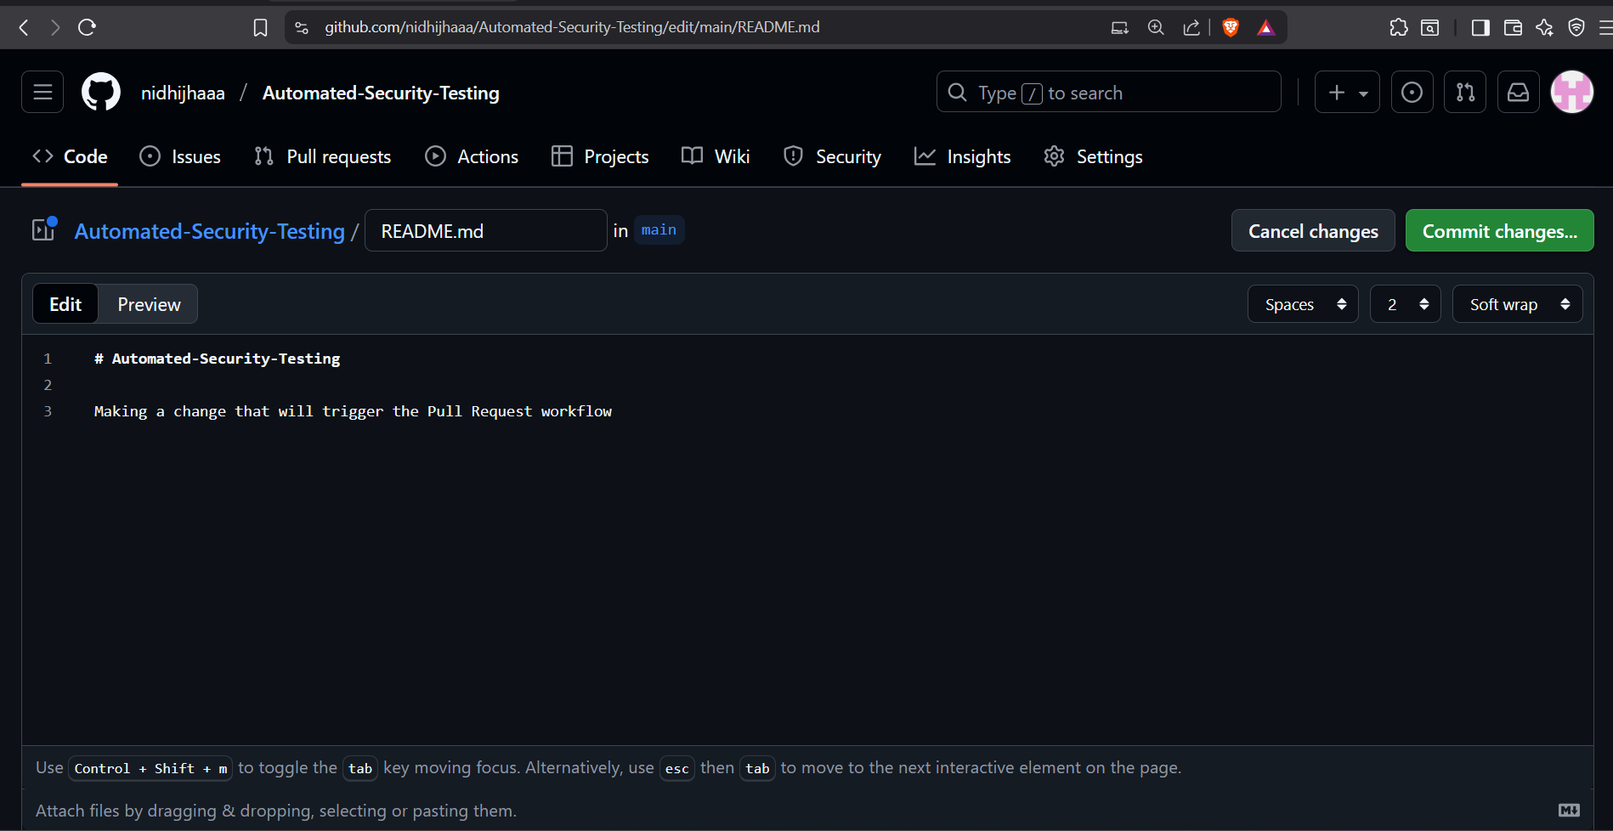

- Commit the Change to a NEW Branch:
  - Select the option: Create a new branch for this commit and start a pull request.
  - Name the branch something like test/dast-scan.
  - Click Propose changes.
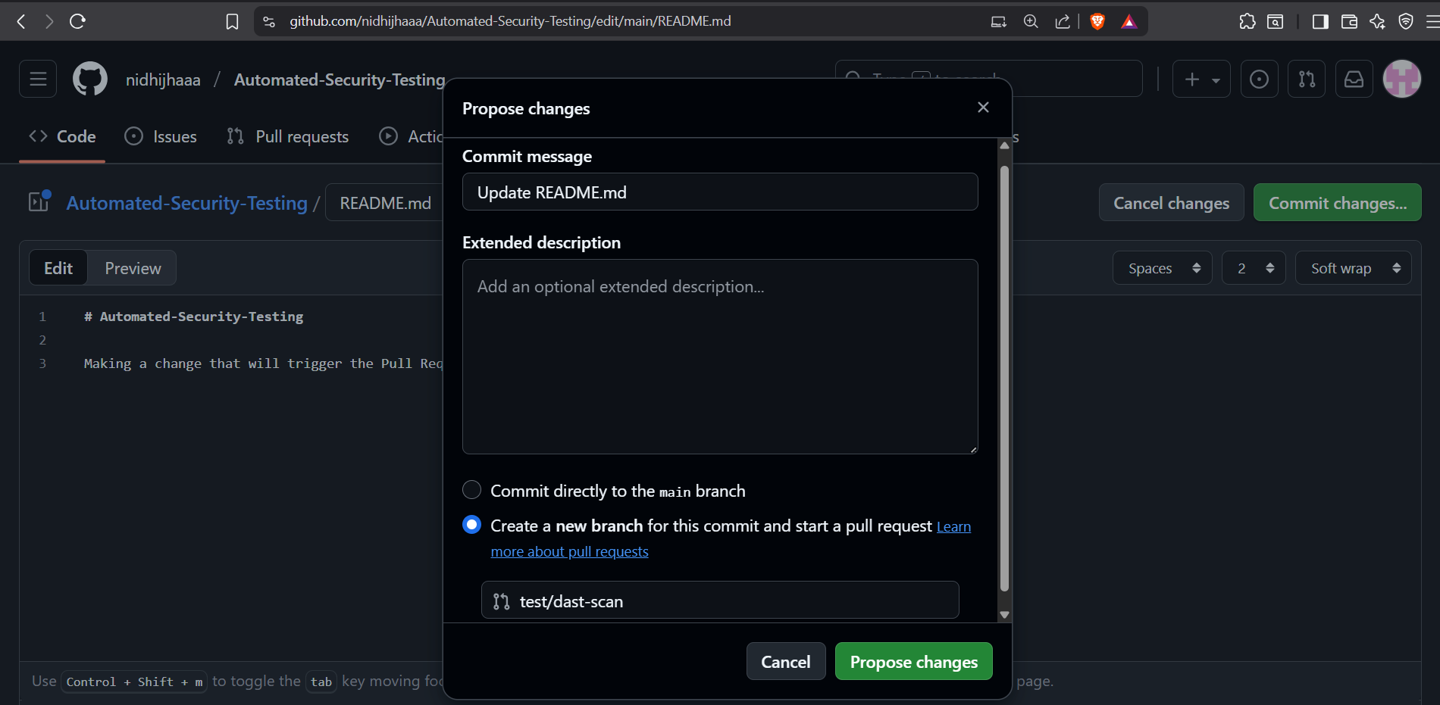

Create the Pull Request:
- On the next screen, click the green Create pull request button. You can title it "Test: DAST Integration"

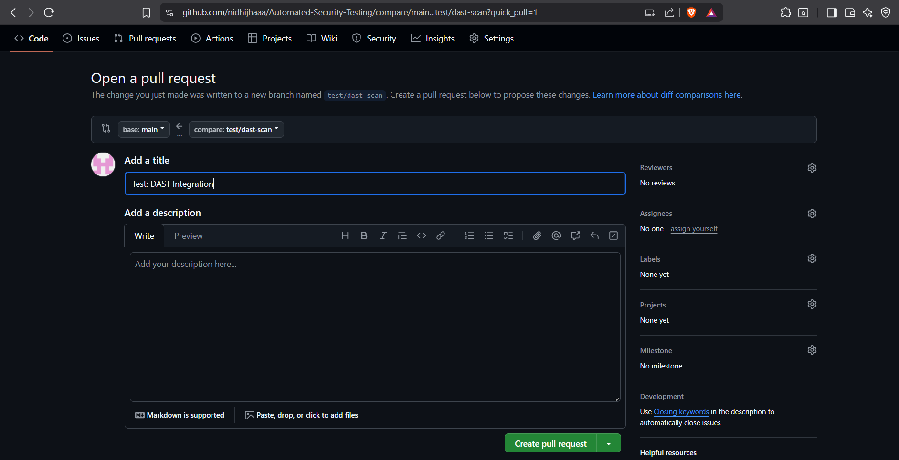

- Go to the Actions Tab: Immediately after creating the PR, navigate to the Actions tab in your repository.

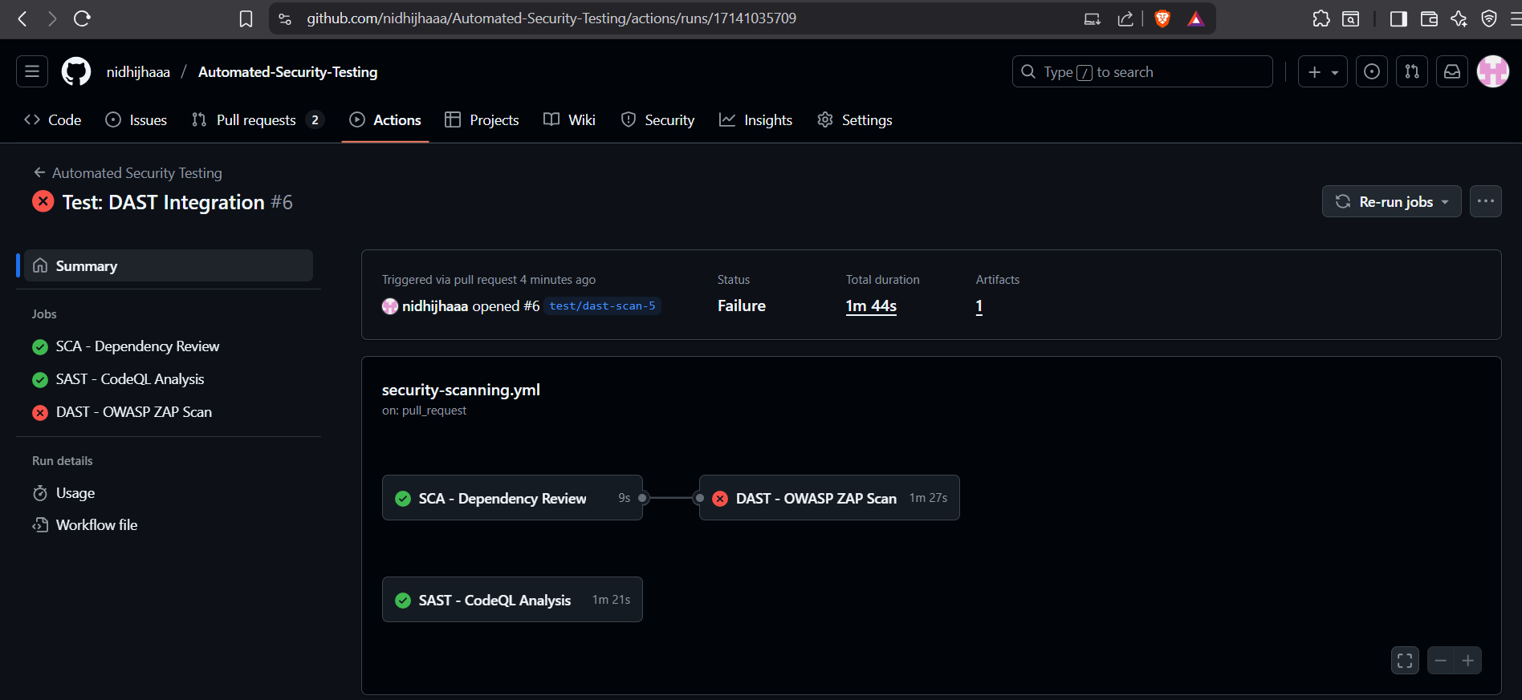

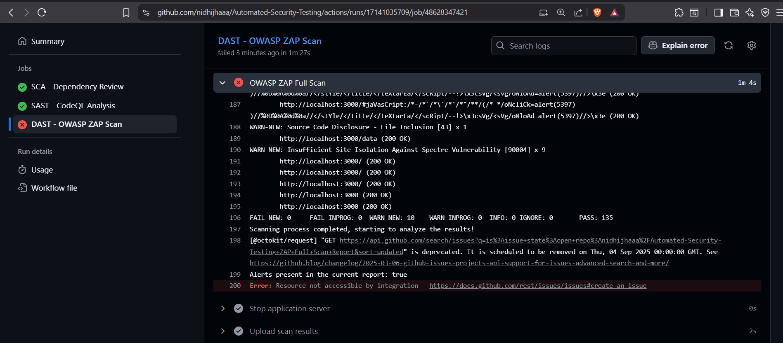

Your Scan Was a Success!
- FAIL-NEW: 0 This is the most important line. It means ZAP found ZERO critical or high-risk vulnerabilities (like SQL Injection, Remote Code Execution, or severe XSS). Your application is secure from the most dangerous attacks.
- PASS: 135 Your application successfully defended against 135 different attack tests.
- WARN-NEW: 10 ZAP found 10 issues, but they are all medium or low-risk warnings, mostly related to best practices.
Conclusion

By implementing automated security testing in GitHub Actions, learners achieve a practical DevSecOps pipeline that continuously evaluates applications against multiple layers of threats.
- SCA ensures third-party dependencies are free from known vulnerabilities.
- SAST highlights insecure coding patterns before deployment.
- DAST, powered by OWASP ZAP, validates application resilience against runtime attacks such as Cross-Site Scripting (XSS) and SQL Injection.

This hands-on exercise not only reinforces secure coding practices but also demonstrates how automation transforms security into a continuous, integrated process.
Ultimately, this workflow empowers developers to shift security left, reduce risk exposure, and deliver applications that are both reliable and resilient in production environments.

